Success stories

- Title of story : Mulching Farming
- Location : At- Tonapathar, Katoria, Banka
- Project Facilitation Agency : Mukti Niketan Bhagalpur
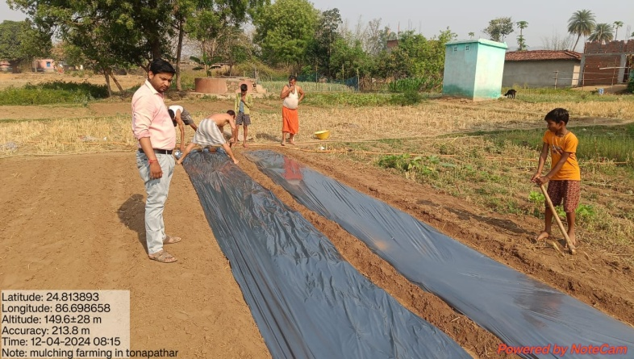
- Problem Description: Mr. bahadur Tanti is very laborious farmer. He is 45 years old with 25 years of farming experience. He used to grow traditional crops on his farm with average yields of various crops before coming in contact withextension functionaries of Mukti Niketan and NABARD. The production in Bahadur Tanti’s field was very low and he was very troubled by the grass. Due to the grass the crop production was low andthere were many insects infesting it.

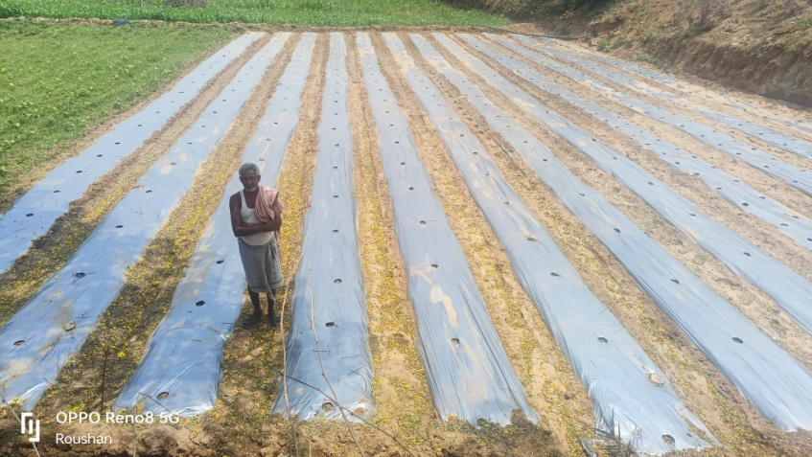
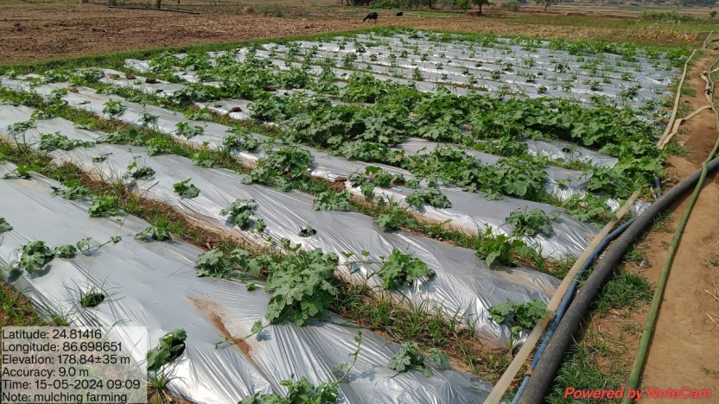
- Initiation taken-Under ‘Mulching Farming’ in KfW soil project Mr. Bahadur tanti was selected. He promised to follow all norms. He bounded the area under this scheme Mukti Niketan provide him vegetables seeds, mulching plastic sheets and organic compost. Bahadur Tanti sowed the seeds o time and spread mulching plastic in the field, soon the plants started sprouting, but due to there being no grass in the field the growth of the crop was very good.
- Progress & Result- the Plants started bearing fruits on time. Bahadur Tanti was very happy as the qualityof the fruit was also very good. After using the vegetables in his home, he started selling them in the nearby market. Due to which he started earning good profits. By farming with this method, Bahadur Tanti got rid of the problem of grass and his profits also started increasing.
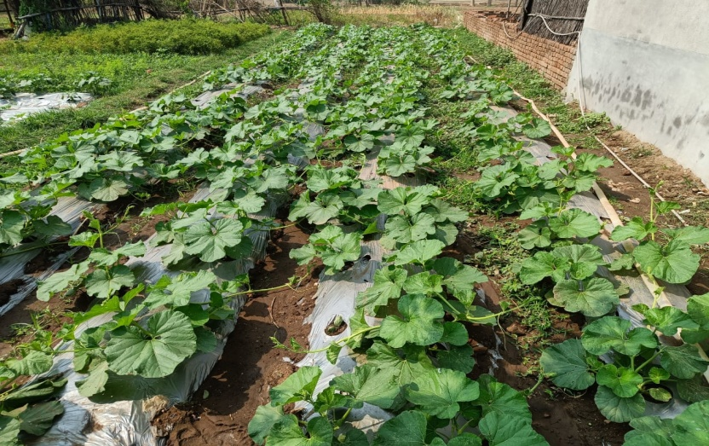
- Impact:Seeing the problem of grass and water shortage, Bahadur Tanti as started mulching farming in more and more field. Seeing the success of Bahadur tanti, other farmers there are also adopting this method.

- Inspiration –He is recognized as a progressive farmer & master Trainer for farmers in the district & farmers are following his steps.

